**JAYPEE UNIVERSITY OF ENGINEERING & TECHNOLOGY** Accredited with Grade-A+ by NAAC & Approved U/S 2(f) of the UGC Act,1956 A.B. Road, Raghogarh, District Guna (MP), India, Pin-473226 

Phone: 07544 267051, 267310-14, Fax: 07544 267011

Website: www.juet.ac.in

**Weekly Progress Report**

**Week No. _2__**

Name: Sapeksh Pareek Enrolment No. 211B274 . Period: 27/05/2024 to 02/06/2024 . Work done during Week (in detail)

This week, I worked on a new SaaS template available on MUI.com in the Material Design section. I focused on fixing errors and bugs, linking pages using React Router, and implementing internal linking with the Link component in React. I used Next.js as the backend and thoroughly explored MUI components by reading the documentation. This process helped me become familiar with various MUI components and their implementation in React, significantly enhancing my development skills and preparing me for more complex tasks in future projects.___________________________

Section/Department of Organization (Under which training is going on)

Develop a scraper tool using Selenium for data collection from a specified social media platform. Create an API using Flask, ensuring it is accessible over the internet, and deploy it on Vercel.__________________________________

Name of Supervisor:Ms. Anahita Zahl Tantra (HR, Yardstick)  
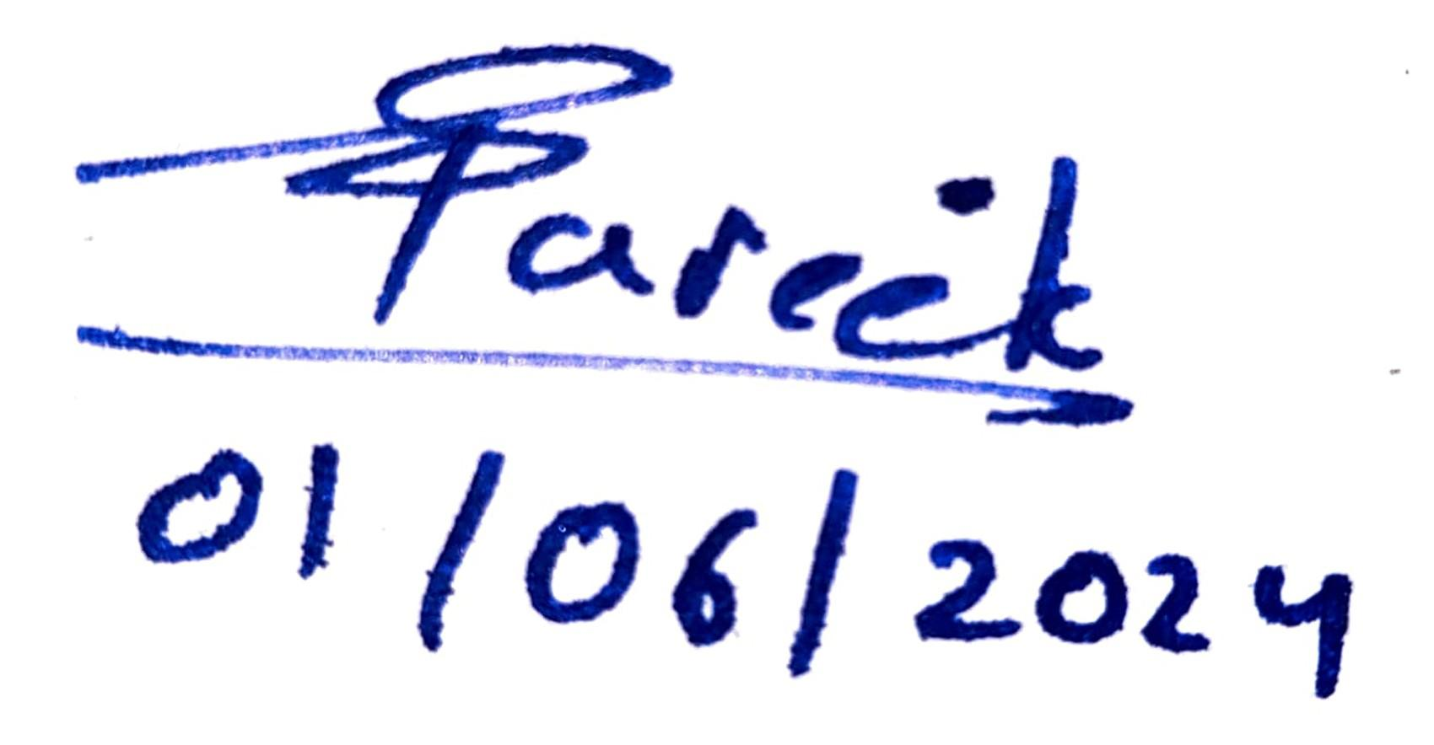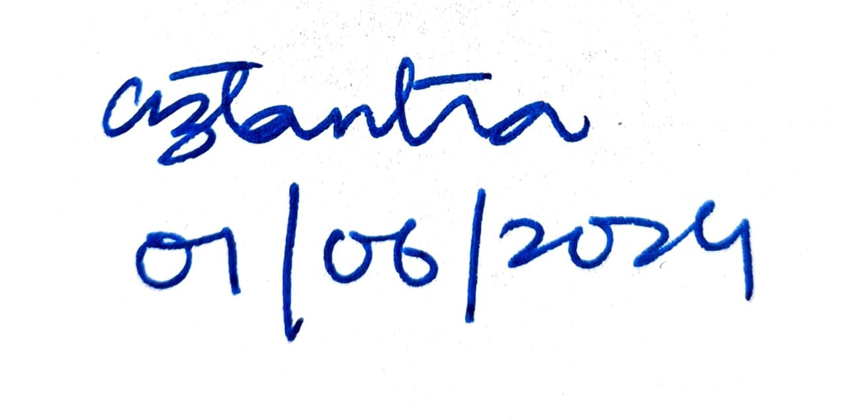

**Signature of Supervisor Signature of Student  
(with date) (with date)**